**Data**

Total Direct Tonnage - Imports (Tonne) monthly (D.Import) and from Total Direct Tonnage - Exports (Tonne) monthly (D.Exports) for year (2000-01 to 2021-11) were collected from the [info@singstat.gov.sg](mailto:info@singstat.gov.sg) [1, 2]. The first 15-year data (2000-2014) were used for model construction and model fitting (Training set) and the remaining seven-year (2015-2021) were used to forecasting and validating the model (Testing set).

Figure 1 shows the Trend of D.Import and D.Export in combine axes(visualizing)

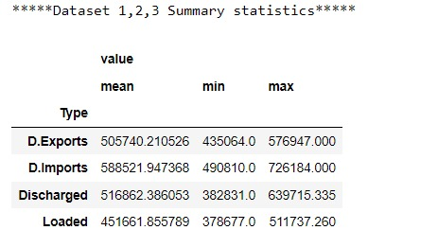

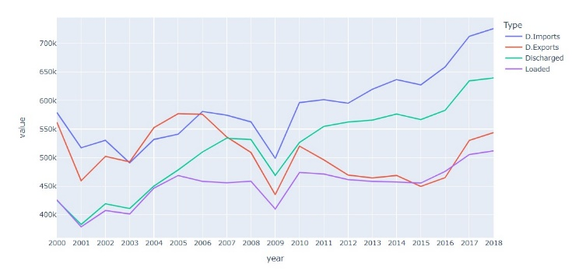

**Decompose the Data (D.Import & D.Export)**

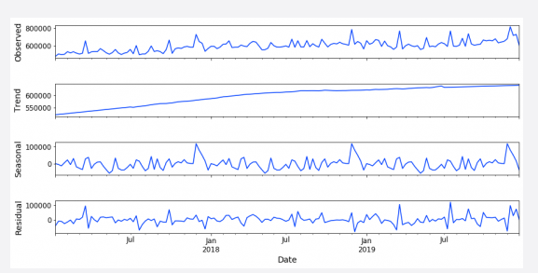

ACF and PACF test

Figure 2 Singapore’s D.Exports & Imports from FY2000-01 to 2012-12 – Non-Stationary and Stationary series

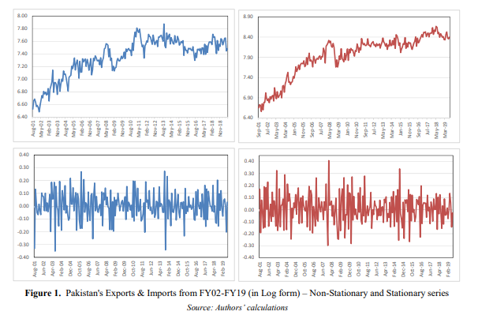

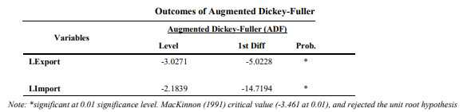

**Find the most suitable ARIMA**

Table 3 AIC results for different ARIMA model variables

Model AIC

ARIMA(0,1,1) 2.556,191

ARIMA(1,1,0) 2.556,513

ARIMA(2,1,2) 2.554,655

ARIMA(3,1,2) 2.552,124

Predicting result of the selected ARIMA Model

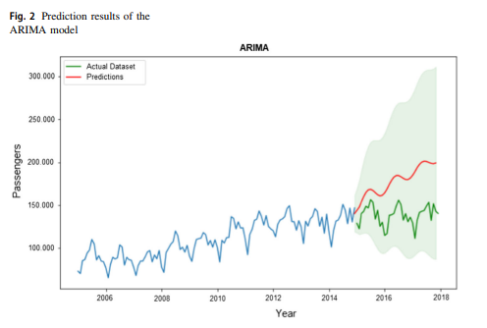

Forecasting Performance of D. Import and D. Export usng ARIMA(p,d,q) model

|  |  |  |  |
| --- | --- | --- | --- |
| Evaluation | D.Import | D.Export | Average |
| MAE |  |  |  |
| RMSE |  |  |  |
| MAPE |  |  |  |
| R2 |  |  |  |

Forecasting Performance of D. Import and D. Export using SARIMAX(p,d,q)(P,D,Q)5

|  |  |  |  |
| --- | --- | --- | --- |
| Evaluation | D.Import | D.Export | Average |
| MAE |  |  |  |
| RMSE |  |  |  |
| MAPE |  |  |  |
| R2 |  |  |  |

Accuracy evaluation of ARIMA, SARIMAX on Fitting and Forecasting D.Import and D.Export

|  |  |  |  |  |  |  |  |  |  |
| --- | --- | --- | --- | --- | --- | --- | --- | --- | --- |
| Data | Model | Model Fitting (in-sample) | | | | Model Forcasting (out-of-sample) | | | |
| MAE | RMSE | MAPE | R2 | MAE | RMSE | MAPE | R2 |
| D.Import | ARIMA  SARIMAX |  |  |  |  |  |  |  |  |
| D.Export | ARIMA  SARIMAX |  |  |  |  |  |  |  |  |